**Question – 1 Write a recursive function to calculate sum of first N natural numbers**

**Ans.**

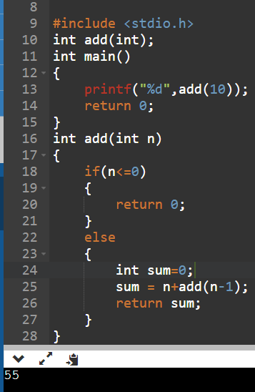

**Question – 2 Write a recursive function to calculate sum of first N odd natural numbers**

**Ans.**

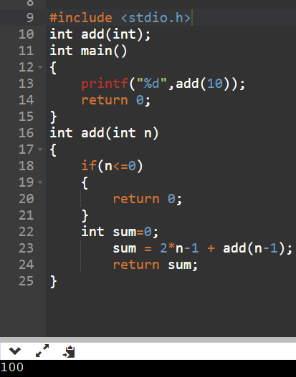

**Question – 3 Write a recursive function to calculate sum of first N odd natural numbers.**

**Ans.**

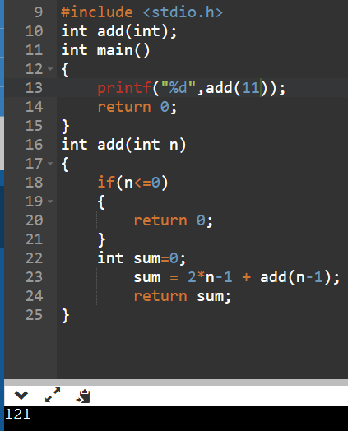

**Question – 4 Write a recursive function to calculate sum of squares of first n natural numbers**

**Ans.**

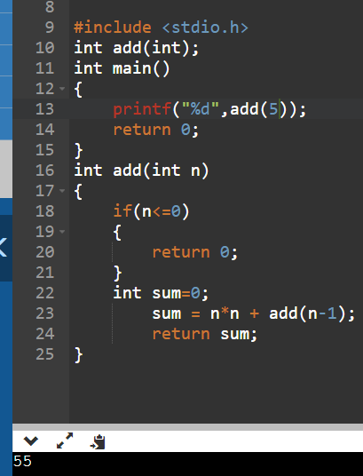

**Question – 5 Write a recursive function to calculate sum of digits of a given number.**

**Ans.**

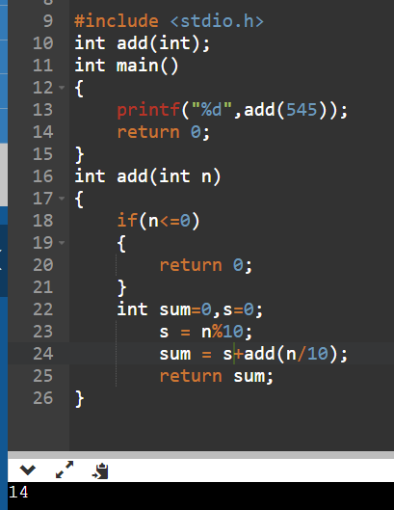

**Question – 6 Write a recursive function to calculate HCF of two numbers**

**Ans.**

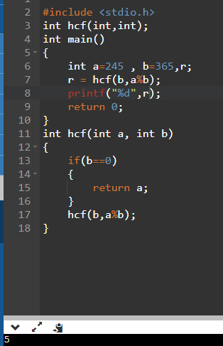

**Question – 7 Write a recursive function to calculate factorial of a given number.**

**Ans.**

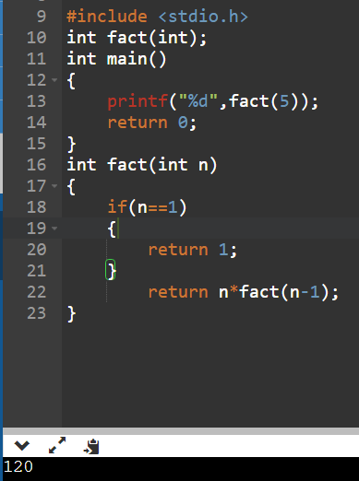

**Question – 8 Write a recursive function to print first N terms of Fibonacci series.**

**Ans.**

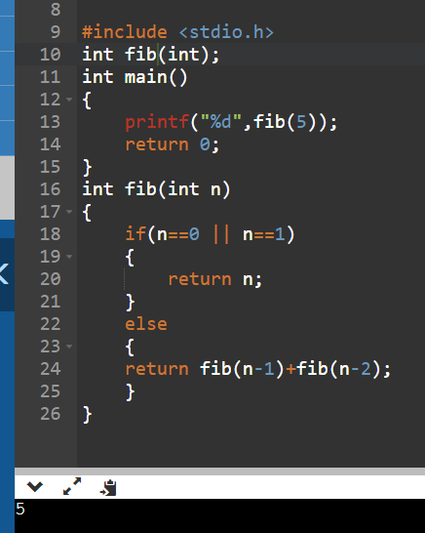

**Question – 9 Write a program in C to count the digits of a given number using recursion.**

**Ans.**

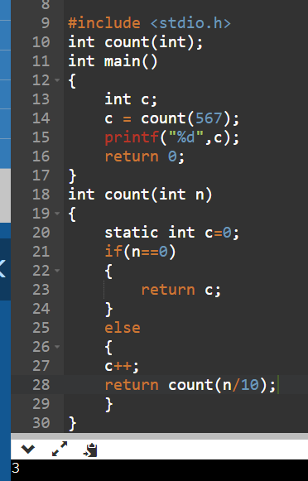

**Question -10 Write a program in C to calculate the power of any number using recursion.**

**Ans.**

